Bonneville Dam (BON) PIT Detection – P2: 478299
PROJECT INFORMATION
P2 Identifier | 478299
Project Manager (PM) | Erin Kovalchuk
Technical Lead (TL) | TBD
Biologist/Coordination | TBD

This project is for installation of a prototype PIT antenna at one of the automatic gates at the Bonneville PH1 Ice and Trash Sluiceway (ITS). The ITS has five gates between the forebay and ITS chute, three auto gates (3B, 6C, and 10B) and two manual chain gates (1A and 1B). The prototype design is for the auto gates.
Fish studies conducted in 2010 and 2011 indicated that 4.3% of yearling Chinook and 5.3% of steelhead traveled downstream through the five ITS gates. This estimate assumed a level of spill occurring in the 2010 and 2011 season. Additionally, an EDR for Bonneville PIT Detection (2019) provided the below estimates of potential PIT detection for the different ITS gates with the following assumptions: 1) spill level commensurate with the 2010 and 2011 season; 2) PIT detection efficiencies as listed below; and 3) that 50% of flow and thus downstream-passing fish went through the manual chain gates 1A and 1B.
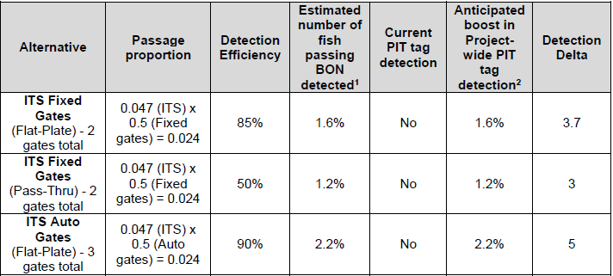
BPA has funded design of a prototype PIT antenna for one of the auto gates. (The two manual gates would require a separate design and installation effort.) FY23 funding would be for review of the antenna design (to ensure no issue with operation of the gate after installation) and Project labor for installation of the prototype.

SCHEDULE & COST

YEAR | COST | MAJOR ACTIVITIES
FY23 Capability | $600k | Review design, installation

